App in a Day

Hands-on Lab Step-by-Step

May 2020

Contents

Importing Module 1 Completed 1

Task 1: Create a new environment 1

Task 2: Import application 2

# Importing Module 1 Completed

Follow the steps below, if you did not complete Module 1 and would like to skip to Module 2

## Task 1: Create a new environment

1. Open a new browser tab, navigate to [Power Apps admin portal](https://admin.powerplatform.microsoft.com/) select **Environments** and click **New Environment**.

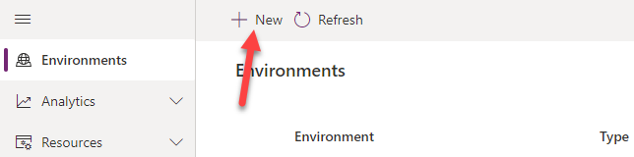

1. Provide an **Environment Name**, select **Trial** for **Type**, select **Region**, select **Yes**, for **Create** a database, and click **Next**.

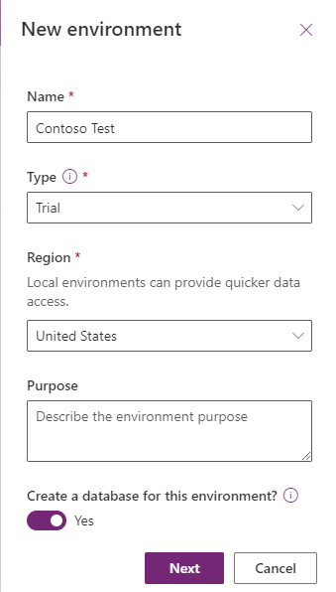

1. Select **Language,** select **Currency**, select **Yes** for **Deploy sample apps** **and data** and then click **Save**.

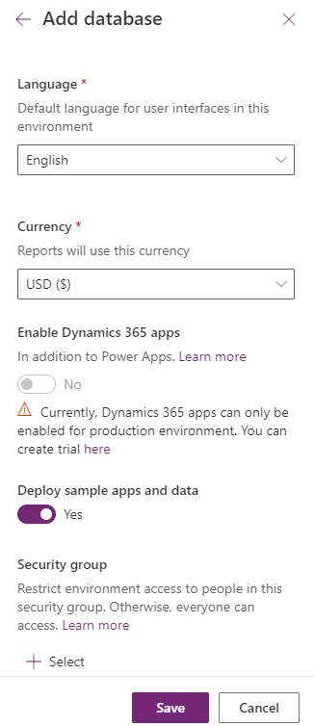

1. Wait for the environment to be created.

## Task 2: Import application

In this task, you will import the completed Module 1 application.

1. Open a new browser tab, navigate to [Power Apps maker portal](Power%20Apps%20maker%20portal)
2. Click on the environment name and select the environment you created in task 1.

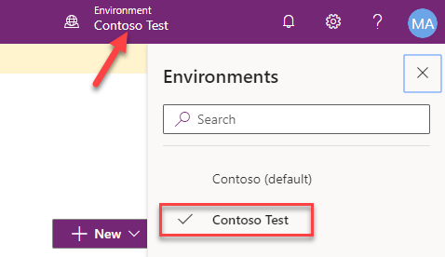

1. Select **Apps** and click **Import canvas app**.

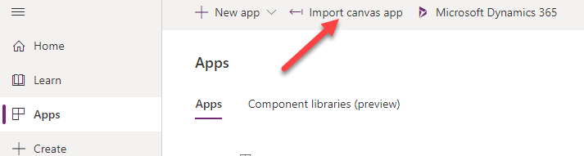

1. Click **Upload**.

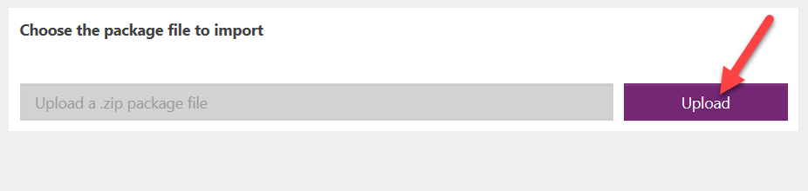

1. Select the zip file located in Module 1 completed folder and click **Open**.

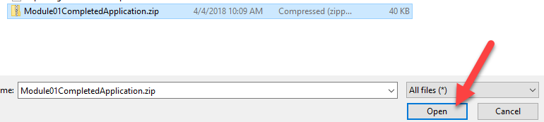

1. Click **Import**.

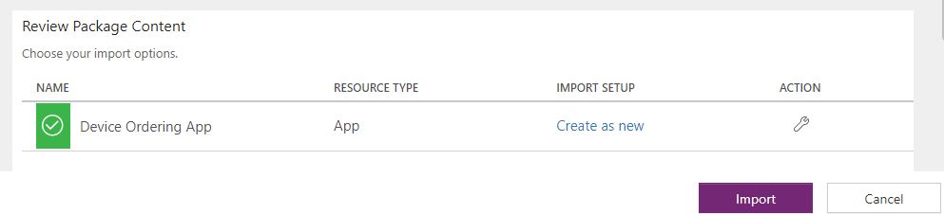

Wait for the application import to complete.

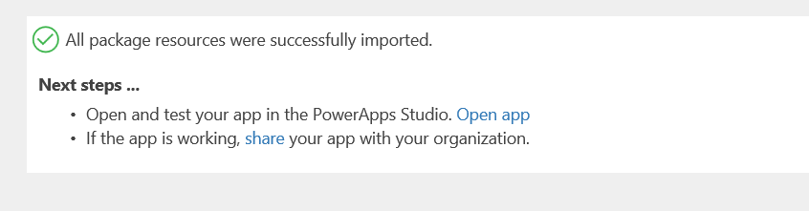

1. Click **Apps**, locate the application you imported, click … and click Play.

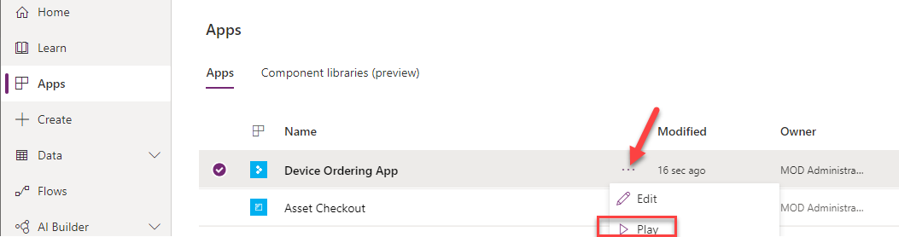

1. Confirm the application loads.

